PROJECT REPORT: SECURE EXPENSE VAULT
Course: Programming in JAVA: Bring Your Own Project (BYOP) Capstone
Author: Shikha Singh (24BAI10244)
Github link: https://github.com/shikhasingh-0508/SecureExpenseVault

- ABSTRACT
( The Idea: Why I Built This? )
In today’s digital world, managing personal expenses has become important for everyone, especially students. However, many simple expense tracking applications store data in plain text, which makes sensitive information unsafe, particularly on shared systems like college computers.
Secure Expense Vault is a Java-based Command Line Interface (CLI) application developed to address this issue. It allows users to record and manage their daily expenses while keeping the daata secure using a basic XOR-based encryption technique.
The project uses core Java concepts such as object-oriented programming, collections like ArrayList and HashMap, and file handling. The aim is to show how even a simple application can be made more secure and practical by adding privacy-focused features.

- INTRODUCTION
Managing money properly is an important skill, especially for students with limited budgets. Many tools are available for tracking expenses, but most of them do not focus much on data security.
In basic applications, data is usually stored exactly as entered, which means anyone with access to the system can read it easily. This can expose personal financial details.
Secure Expense Vault works like a small digital locker. It uses a master password for access and encrypts stored data so that it cannot be understood directly. The goal is to keep the system simple while also improving security.

- PROBLEM STATEMENT
Most simple Java-based expense trackers store data in CSV format. This creates two main problems:
Security Issue:
Data is stored in plain text and can be opened easily using Notepad or Excel.
Data Handling Issue:
If the user enters commas in descriptions (like “Pizza, Coke, and Fries”), the CSV format breaks and may cause errors.
So, there is a need for a system that protects data and also handles flexible user input without errors.

- OBJECTIVES
- To build a simple expense tracker using core Java
- To implement a basic login system using a master password
- To secure stored data using encryption
- To provide CRUD operations (Create, Read, Delete, Calculate)
- To generate category-wise summaries
- To handle user input safely without breaking the system

- SCOPE OF THE PROJECT
This project is a single-user, offline application. It does not require internet or external databases, so it is lightweight and easy to run.
The main focus is on:
- Core Java programming
- Data handling using collections
- Secure file storage
Advanced features like GUI or cloud storage are not included, as the goal is to focus on fundamentals.

- SYSTEM ARCHITECTURE
The system is divided into different parts:
- Security Layer: Handles password and encryption
- Data Model: Represents expense data
- Logic Engine: Manages operations and file handling
- User Interface: CLI-based interaction
Basic Flow:
Start Program - Enter Password - Load & Decrypt Data - Perform Actions - Encrypt & Save - Exit

- TECHNOLOGIES USED
- Language: Java (JDK 11+)
- IDE: VS Code
- Data Structures:
  - ArrayList (for storing expenses)
  - HashMap (for category totals)
- Libraries:
  - java.util.*
  - java.io.*
- Version Control: Git & GitHub

- MODULE DESCRIPTION
(How I Built It: The Technical Choices? )
To keep the architecture clean, I split the project into modular components using core Object-Oriented Programming (OOP) principles.
Instead of relying on heavy external databases, I wanted to handle the memory and File I/O manually to really test my Java skills. Here are the key technical decisions I made:
- The Logic Engine (HashMap over Loops): When building the feature that summarizes spending by category, I could have used nested loops. Instead, I used a HashMap. It allowed me to map the categories (like "Food" or "Travel") to their total costs dynamically in a single pass, making the program much more efficient.
- The Security Layer (XOR Encryption): To protect the .txt file where the data is permanently saved, I wrote a custom bitwise XOR cipher. Before any data is saved, it passes through this cipher using a secret key, turning it into unreadable characters. It’s lightweight but incredibly effective for local privacy.
- Full CRUD Functionality: I didn’t just want a script that adds numbers to a list. I built out full Create, Read, and Delete functionalities, requiring me to assign dynamic index IDs to the expenses so they could be precisely managed.

1. Expense Model (Expense.java)
Stores details of each expense like date, category, amount, and description.
Uses encapsulation and provides a method to convert data into storable format.
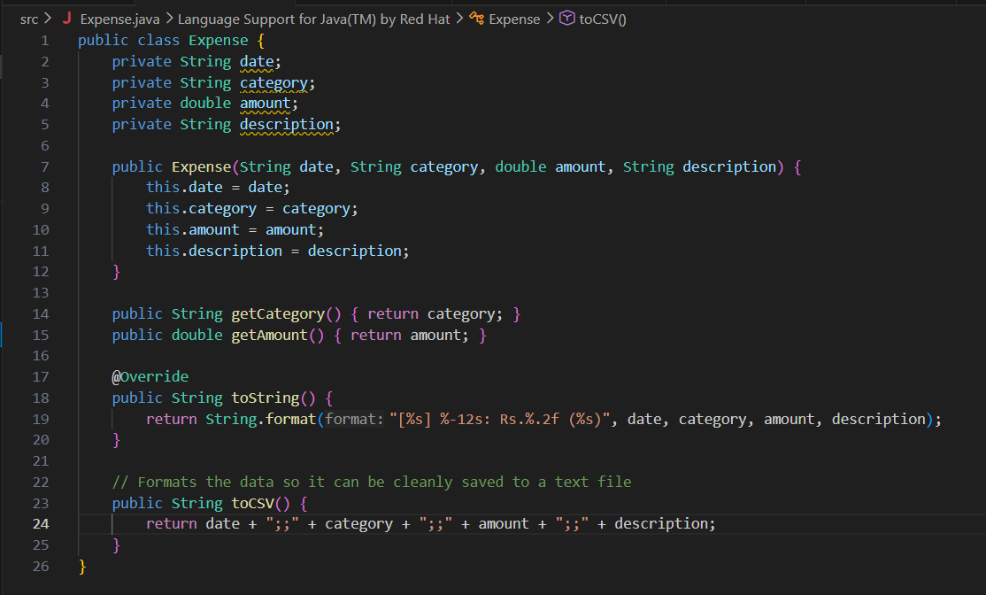
2. Security Layer (Security.java)
Handles login and encryption.
Uses XOR cipher for both encryption and decryption.
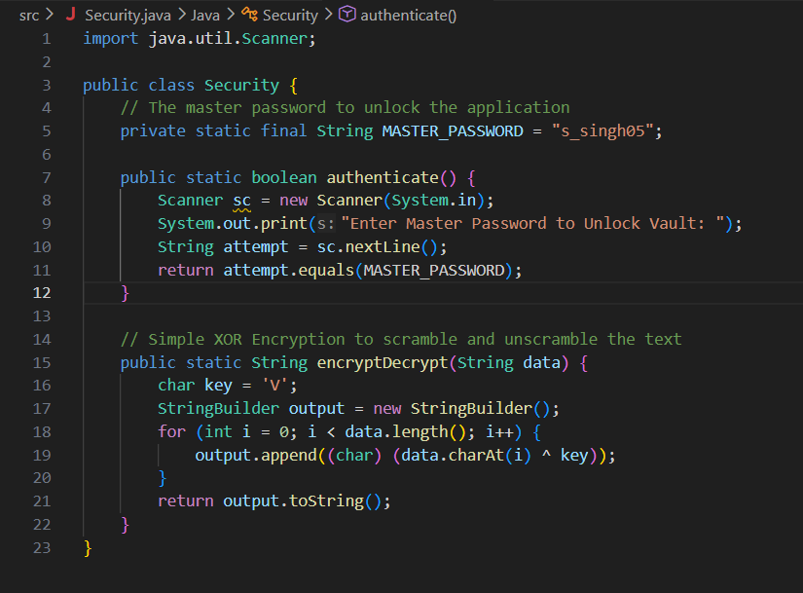
3. Logic & Storage (ExpenseManager.java)
Main working module of the system:
- Stores data using ArrayList
- Uses HashMap for calculations
- Handles file reading/writing with exception handling
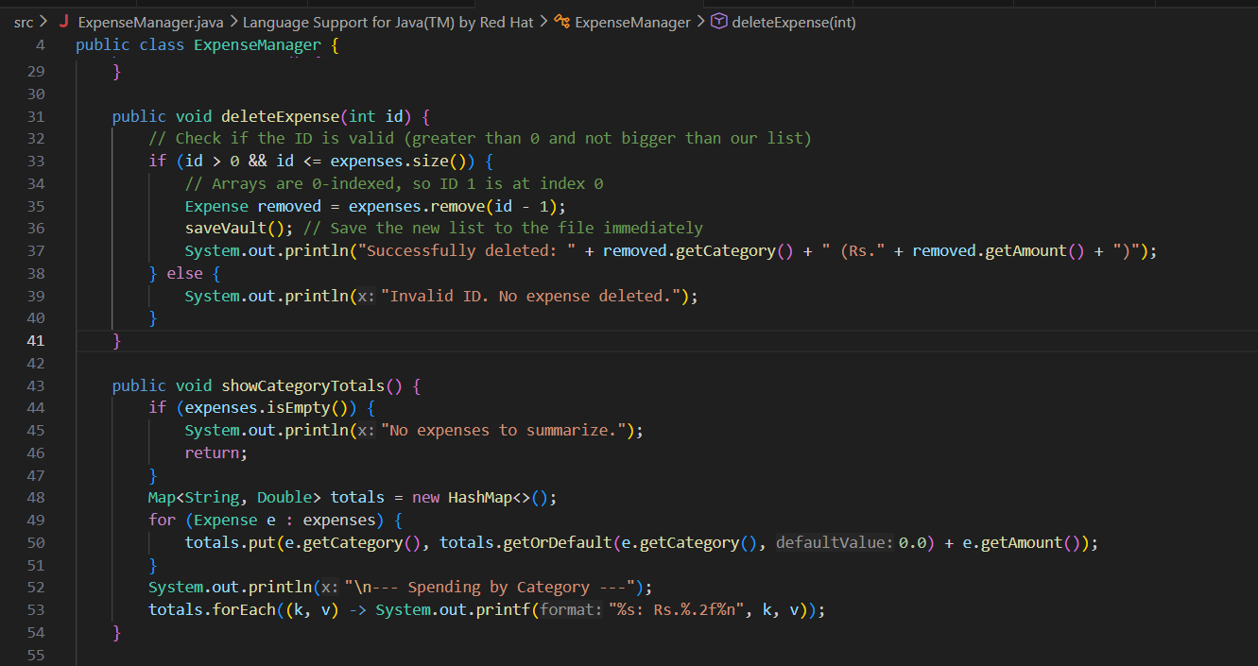
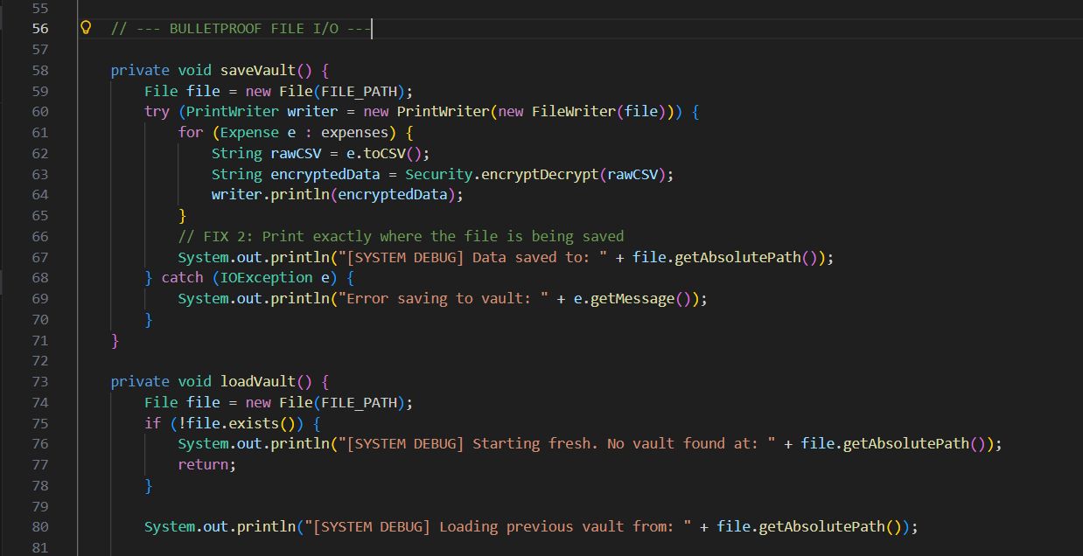
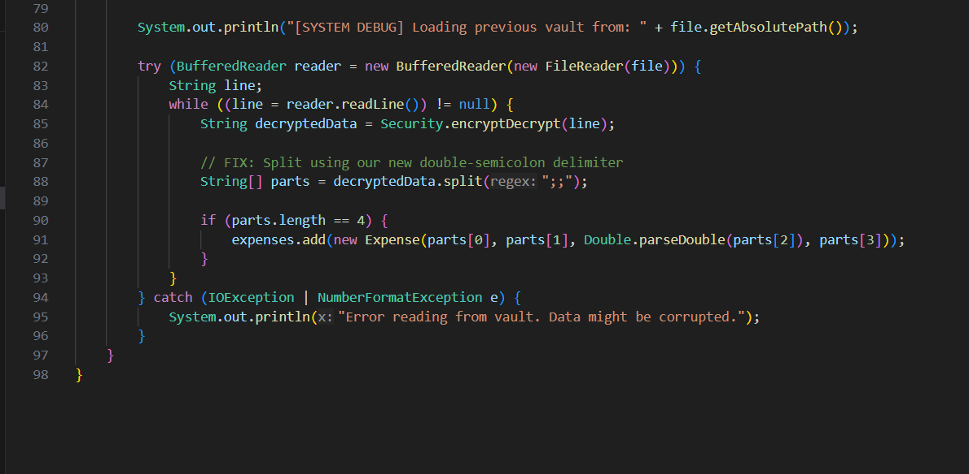

4. User Interface (Main.java)
Menu-driven CLI system.
Includes basic input validation to avoid crashes.
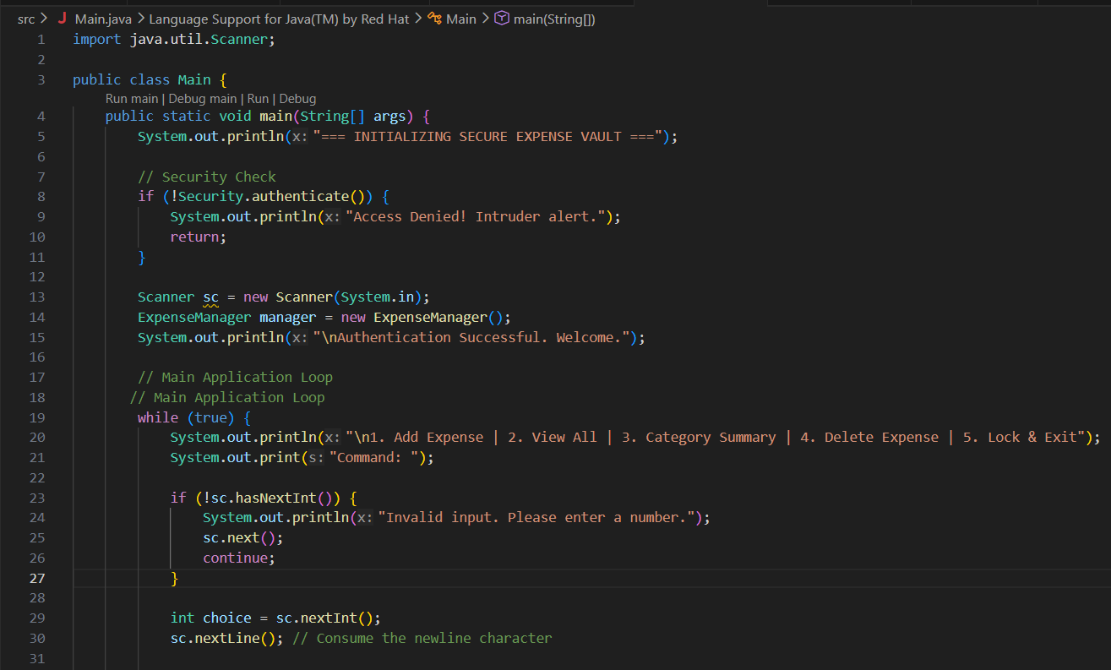
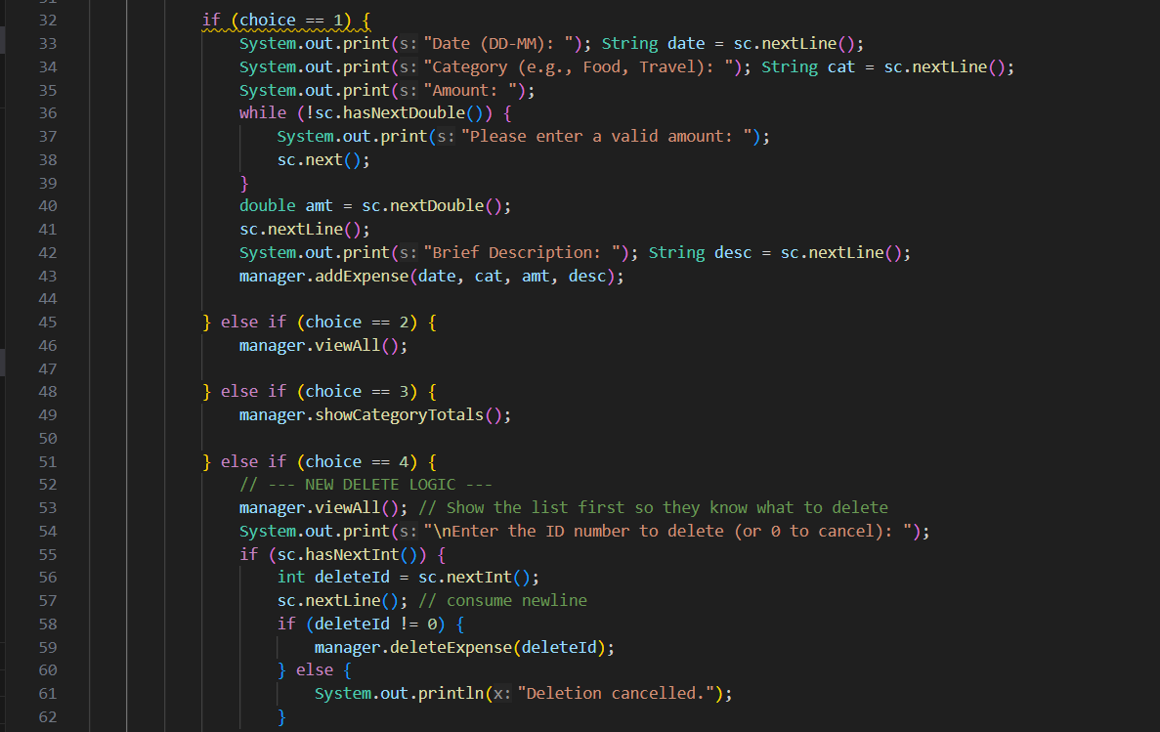
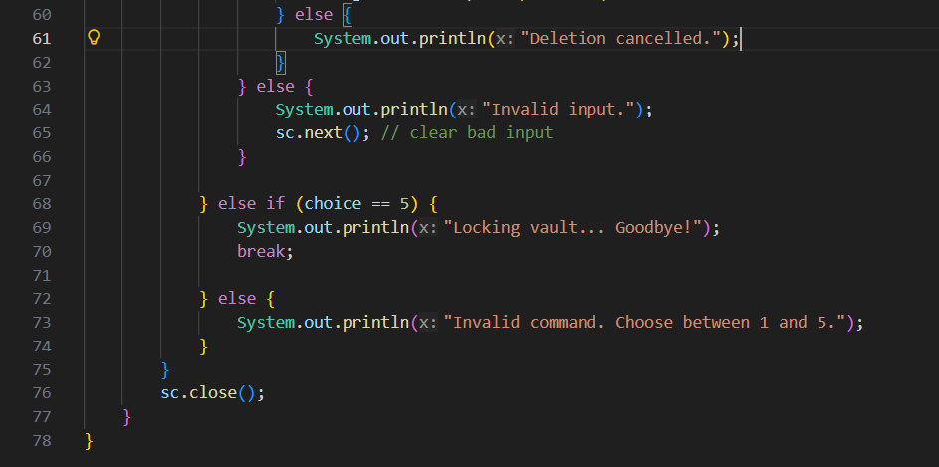

- ENCRYPTION & DATA HANDLING
A simple XOR cipher is used instead of complex encryption to demonstrate basic security concepts.
Also, a custom delimiter ;; is used instead of commas to avoid errors when users enter commas in descriptions.
Story behind it:- The Biggest Challenge: The "Comma" Bug
he most interesting part of this build wasn't the encryption—it was a data parsing bug.
Initially, I formatted the saved data as a standard Comma-Separated Value (CSV) string. Everything worked perfectly until I tested it with a real-world description: "Noodles: 130, Cold-Drink: 70, Pizza:190, Ice-cream: 60".
When I restarted the app, the program crashed. Because my description contained a comma, the String.split(",") method broke my data into too many pieces, bypassing my safety checks and corrupting the file logic.
The Fix: This was a great lesson in never trusting user input. I had to completely refactor my toCSV() formatting and my file-loading logic to use a double-semicolon (;;) as the delimiter instead. Once I made that change, the vault became totally bulletproof against whatever text I threw at it.

- FEATURES
- Password-protected access
- Add and delete expenses
- View all records
- Category-wise summaries
- Auto-save functionality

- ADVANTAGES
- Improves data privacy
- Works offline
- Simple and lightweight
- Handles input safely

- LIMITATIONS
- No graphical interface
- Only one user supported
- Password is hardcoded

- FUTURE IMPROVEMENTS
- Add GUI using Swing or JavaFX
- Use stronger encryption (like AES)
- Add password hashing
- Export data to CSV/Excel

- TESTING AND VALIDATION :-

The system was tested with various scenarios, including correct and incorrect password attempts, multiple expense entries, data persistence across sessions, and verification of encrypted file contents. The results confirmed that the application functions correctly and securely.

- CONCLUSION
The Secure Expense Vault successfully proves that robust data security and error-resistant parsing can be engineered into lightweight, everyday applications. By stepping away from simple array management and integrating File I/O with custom cryptography and delimiter logic, the project evolved from a standard classroom exercise into a practical, real-world utility. It highlights the importance of anticipating edge cases in user input and demonstrates a strong command of Java's object-oriented principles, data structures, and stream processing.

- What I Learned:
Building the Secure Expense Vault was a massive step up from writing standard classroom algorithms. It taught me how to handle application state and how to safely move data between temporary RAM and permanent hard drive storage.
More importantly, it showed me that as developers, we have to think about security and edge cases from day one. An app isn't just about making the code compile; it's about making sure the program doesn't crash when a user types the wrong character, and making sure their data stays private long after the application is closed.
Overall, combining core Java data structures with file handling and basic cryptography resulted in a project I am genuinely proud of.

- References
- Oracle. Java Documentation (JDK 11)
https://docs.oracle.com/en/java/
- GeeksforGeeks. Java Programming Tutorials
https://www.geeksforgeeks.org/java/
- TutorialsPoint. Java File Handling and Collections
https://www.tutorialspoint.com/java/
- AES Encryption Standards
- Basic Cryptography Concepts (XOR Cipher)
https://www.geeksforgeeks.org/xor-cipher/

